Architecture Document for
<AI-Led Test Case Optimization>

.........
<AI-led Test Case Optimization>-<Component>-AD-<1.0>

Table of Contents

1 Introduction – PART-A 1
1.1 Purpose 1
1.2 Scope 1
1.3 Definitions, Acronyms and Abbreviations 1
1.4 References 1
2 Architectural Goals and Constraints - – PART-B 2
2.1 Reusability 2
2.2 Scalability 2
2.3 Customizability 2
2.4 Extendibility 2
2.5 Use of Existing Business Logic 2
2.6 Time to Market 2
2.7 Portability 2
2.8 Availability 3
3 Productization Assessment – PART-B 3
3.1 Re-Usable Components 3
3.2 Analyze Architectural Frameworks in Repository 3
3.3 Identify and Analyze Open Source and COTS Products 3
4 System Architecture – PART-A/B 3
4.1 Overview - – PART-A 3
4.2 Logical/Functional View - – PART-A 4
4.3 Use Case View – PART-A 7
4.4 Deployment View – PART-B 8
5 Alternative Solutions Considered – PART-B 10

Document Revisions
Date | Version | Description | Author
01-05-2023 | 1.0 | PART-A | Harsha’s Team (Palagiri Ganesh Harsha)
08-05-2023 | 1.1 | PART-A + PART -B | Harsha’s Team (Palagiri Ganesh Harsha)

Introduction – PART-A

Purpose

This document provides a comprehensive architectural overview of the AI-led Test Case Optimization system, utilizing artificial intelligence and machine learning techniques to enhance the efficiency and effectiveness of test case management. It aims to outline the significant architectural decisions made in the development of the system.

Scope

The scope of this document encompasses the architectural aspects of the AI-led Test Case Optimization system. It covers the design and implementation of the system's components, algorithms, and integration points related to test case optimization. However, it does not delve into the detailed implementation of individual algorithms or machine learning models.

Definitions, Acronyms and Abbreviations

AI: Artificial Intelligence
ML: Machine Learning
Test Case: A set of conditions or inputs executed to determine whether a system or component functions as intended.
Optimization: The process of finding the best or most efficient solution given specific constraints or objectives.

References

Smith, J. (2022). "Test Case Optimization: Principles and Techniques." Technical Report TR-2022-001. Available at: [URL]
AI Research Group. (2021). "Machine Learning Algorithms for Optimization." Internal Document.
IEEE Standard Glossary of Software Engineering Terminology. (1990). IEEE Std 610.12-1990

Architectural Goals and Constraints - – PART-B
The AI-led Test Case Optimization system should be designed to facilitate the reuse of its user interface components in the second phase of the back-end data server enhancement project. The core UI system should be modular and adaptable for integration into the RDBMS-based enhancement project.

Reusability

The AI-led Test Case Optimization system should be designed to facilitate the reuse of its user interface components in the second phase of the back-end data server enhancement project. The core UI system should be modular and adaptable for integration into the RDBMS-based enhancement project.

Scalability

The system should be designed to handle scalability requirements effectively. It should be able to accommodate a growing number of test cases and datasets without significant performance degradation. Considerations should be made to optimize resource utilization and minimize bottlenecks.

Customizability

The user interface of the AI-led Test Case Optimization system should support customization. It should provide options for users to personalize the interface according to their preferences, such as adjusting layout, colors, and displaying relevant metrics.

Extendibility

The system should be designed to support easy integration of new features and functionalities. The architecture should be modular, allowing for the addition of new algorithms, optimization techniques, and data analysis methods. Clear interfaces and abstraction layers should be defined to facilitate future enhancements.

Use of Existing Business Logic

The AI-led Test Case Optimization system should leverage existing business logic from the current application. The system should encapsulate the existing logic into reusable components, such as DLLs (Dynamic Link Libraries), to promote code reuse and reduce development efforts. This approach can help maintain consistency and reliability across different phases of the project.

Time to Market

Time constraints for the project's release to the market should be taken into account during the architectural decisions. Consideration should be given to choosing appropriate technologies and frameworks that facilitate rapid development and deployment. Evaluation of technologies like VB COM (Component Object Model) or ATLs (Active Template Libraries) can be performed to meet time-sensitive requirements.

Portability

The AI-led Test Case Optimization system should be designed to be portable across different operating systems and databases. The architecture should abstract away platform-specific dependencies and provide compatibility with commonly used environments. This ensures flexibility and facilitates deployment on diverse infrastructures.

- OS and Database Portability is Available.

Availability

The system should address uptime constraints and incorporate fault-tolerant mechanisms. Measures such as redundancy, load balancing, and error handling should be implemented to minimize downtime and ensure high availability. The architecture should support fault tolerance, fault recovery, and graceful degradation to handle potential failures gracefully.

Productization Assessment – PART-B

Re-Usable Components

Upon analyzing the requirements document for the AI-led Test Case Optimization system, the Productization specialist has identified the following reusable components:

User Interface (UI) Components: The UI components of the system can be designed and implemented in a modular manner to allow for reuse in the second phase of the back-end data server enhancement project. The core UI system can be extracted into reusable components, ensuring commonality and facilitating customization based on specific project requirements.

Test Case Optimization Algorithms: The algorithms used for test case optimization, such as the Artificial Bee Colony (ABC) algorithm, can be implemented as reusable components. These components can be encapsulated and provided as libraries or modules, allowing for easy integration into future projects or enhancements.

Fitness Function Evaluation: The fitness function evaluation logic, responsible for assessing the quality of test cases based on the dataset, can be designed as a reusable component. It can be abstracted and encapsulated in a separate module or library to promote code reuse and maintain consistency across different phases of the project.

Analyze Architectural Frameworks in Repository

The Productization specialist has performed an analysis of the architectural frameworks available in the repository. The identified frameworks that can be reused in the AI-led Test Case Optimization system include:
Machine Learning Frameworks: Frameworks like scikit-learn, TensorFlow, or PyTorch can be leveraged for implementing machine learning algorithms used in test case optimization. These frameworks provide a wide range of tools and functionalities that can expedite the development process and enhance the performance of the AI/ML components.
Data Processing Frameworks: Libraries such as NumPy and Pandas can be utilized for efficient data processing and manipulation. They offer functionalities for handling large datasets, performing mathematical operations, and facilitating seamless integration with machine learning algorithms.

Identify and Analyze Open Source and COTS Products

During the analysis, the Productization specialist has identified the following open-source and Commercial Off-The-Shelf (COTS) products for potential use in the project:

OpenAI GPT-3.5 Model: The OpenAI GPT-3.5 model can be considered for its natural language processing capabilities, which can be utilized for text-based analysis and optimization of test cases. Integration with this model may require compliance with OpenAI's licensing and usage guidelines.

Python Machine Learning Libraries: Open-source libraries like scikit-learn, TensorFlow, or PyTorch can be employed for implementing machine learning algorithms and models in the AI-led Test Case Optimization system. These libraries provide a wide range of pre-built algorithms and utilities, speeding up development and ensuring robustness.

Data Visualization Tools: Open-source data visualization tools like Matplotlib or Plotly can be used to generate visual representations of test case optimization results. These tools enable the creation of informative plots and graphs, aiding in the analysis and interpretation of the optimization outcomes.

System Architecture – PART-A/B

This section describes the software architecture of the current system, and how it is represented. Out of the Logical, Use Case, Implementation, Process and Deployment views, it enumerates the views that are necessary, and for each view, explains the types of model elements it contains.

Models | XML compliant tool
Diagrams | .svg format

Overview - – PART-A

The application architecture for the AI-led Test Case Optimization system is structured into three tiers: User Interface Services, Business Services, and Data Services. Each tier is responsible for specific functionalities and interacts with the others through well-defined interfaces. This tiered architecture promotes modularity and separation of concerns.
The application is divided into three tiers: User Interface Services, Business Services and Data Services. Each layer is responsible for handling a well-defined area of the application.

Logical/Functional View - – PART-A

The logical architecture of the AI-led Test Case Optimization system can be represented using a Package and Layering Diagram, which provides a high-level overview of the logical components and their relationships. This diagram helps to visualize the organization and interactions of the system's components.

In the logical/functional view, the following components and their relationships can be depicted:
User Interface Services:
User Interface Components: This package represents the user interface components responsible for presenting information to users and capturing their input. It includes screens, forms, buttons, and other UI elements.

Presentation Logic: This package encapsulates the logic related to the presentation and interaction aspects of the user interface. It handles events, user input validation, and rendering of data.
Business Services:

Test Case Optimization Algorithms: This package contains the implementation of the AI/ML algorithms used for test case optimization, such as the Artificial Bee Colony (ABC) algorithm. It includes modules for generating and evolving test cases based on the defined fitness function.

Fitness Function Evaluation: This package encompasses the logic for evaluating the fitness of test cases using the provided dataset. It calculates the fitness value based on the defined equation and determines the quality of the test cases.

Integration and Orchestration: This package handles the integration of different components, orchestrating the execution flow, and coordinating the interactions between user interface services and data services.

Data Services:

Dataset Access and Management: This package is responsible for accessing and managing the dataset used for test case optimization. It includes modules for loading the dataset, performing data preprocessing if required, and providing data to the optimization algorithms.

External Data Integration: This package handles the integration with external data sources or services, such as retrieving additional data for enhancing the optimization process or storing the results of the optimization.

The application is comprised of several key architectural components that are independent functions related only via the defined interfaces.

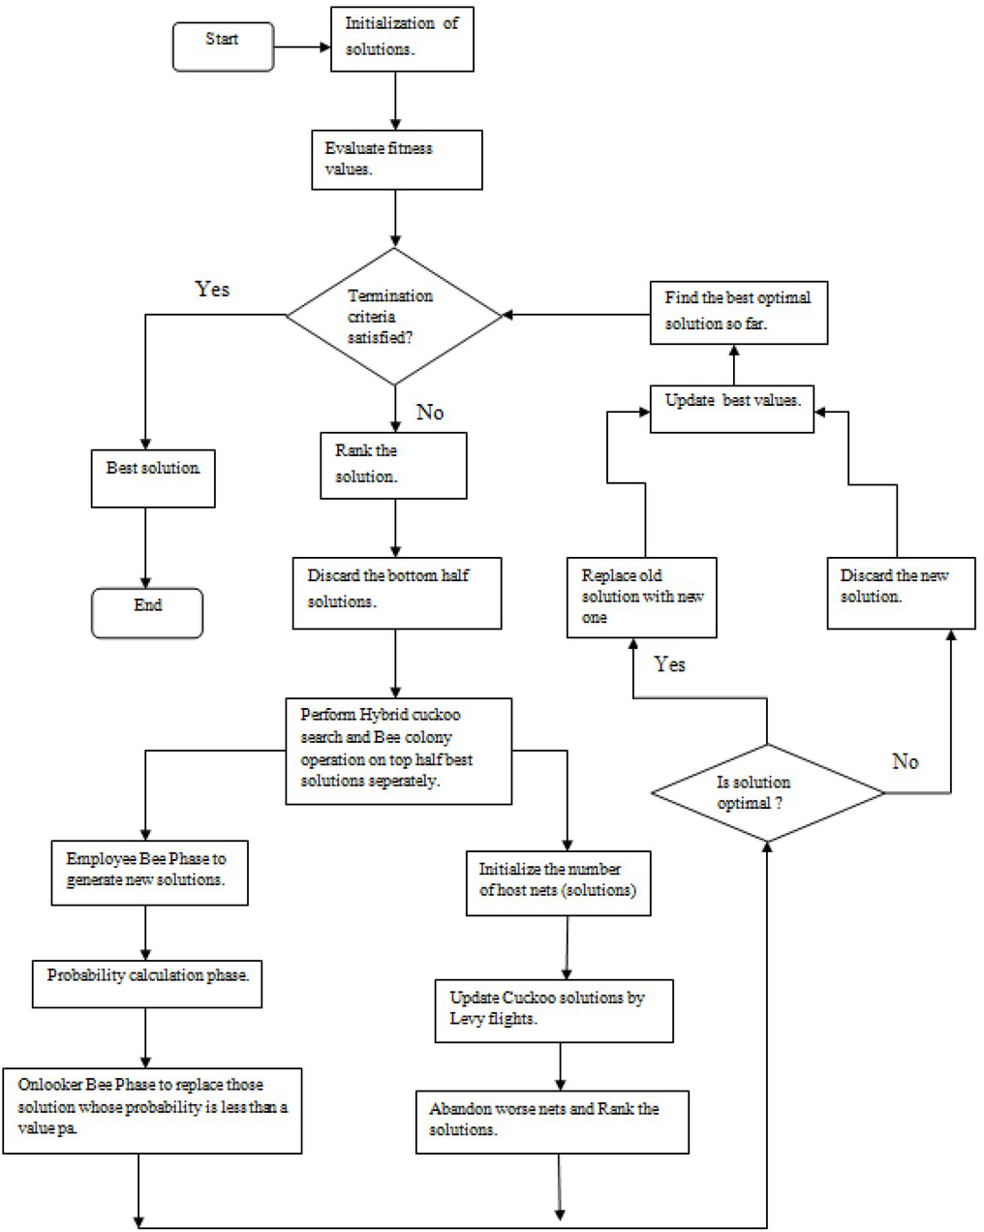

FIG 4.2(a) Logical and Functional View of Project
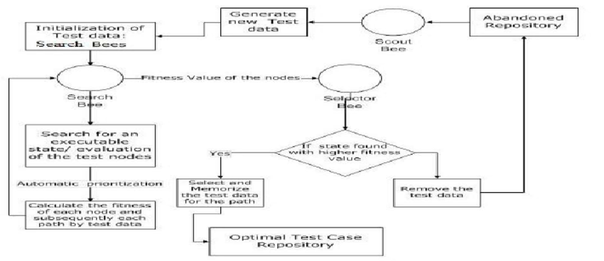

Fig 4.2 (b) Architecture Model of the Project

Use Case View – PART-A

The use case view describes the functional requirements and scenarios of the system from the perspective of the actors interacting with it. Based on the provided case study and the code snippet, we can design the following use cases for the AI-led Test Case Optimization system:
Optimize Test Cases:
Actor: User
Description: This use case allows the user to initiate the optimization of test cases using the AI/ML algorithms.
Main Flow:
The user selects the "Optimize Test Cases" option.
The system presents the available programs as case studies (e.g., Program1, Program2).
The user selects a specific program as the optimization target.
The system retrieves the dataset associated with the selected program.
The system applies the AI/ML optimization algorithms to generate optimal test cases.
The system presents the optimized test cases to the user.
Alternative Flows:
If no dataset is available for the selected program, the system notifies the user and prompts for dataset upload or selection from an external source.
If the optimization process encounters errors or fails, the system provides error messages and suggests troubleshooting steps.
Execute Test Cases:
Actor: User
Description: This use case allows the user to execute the generated or selected test cases.
Main Flow:
The user selects the "Execute Test Cases" option.
The system presents the available test cases for execution.
The user selects one or multiple test cases to execute.
The system executes the selected test cases on the target program.
The system captures the results of the test case execution.
The system presents the test case results to the user.
Alternative Flows:
If no test cases are available for execution, the system notifies the user and suggests running the test case optimization process first.
If the test case execution encounters errors or fails, the system provides error messages and suggests troubleshooting steps.
Adjust Optimization Parameters:

Actor: User
Description: This use case allows the user to adjust the parameters used in the test case optimization process.
Main Flow:
The user selects the "Adjust Optimization Parameters" option.
The system presents the current optimization parameters (e.g., fitness thresholds).
The user modifies the parameters according to their preferences.
The system applies the updated parameters in the optimization process.
The system notifies the user of the parameter adjustments and their impact on the optimization results.
Alternative Flows:
If the user modifies invalid or out-of-range values for the optimization parameters, the system provides validation messages and prompts for valid inputs.
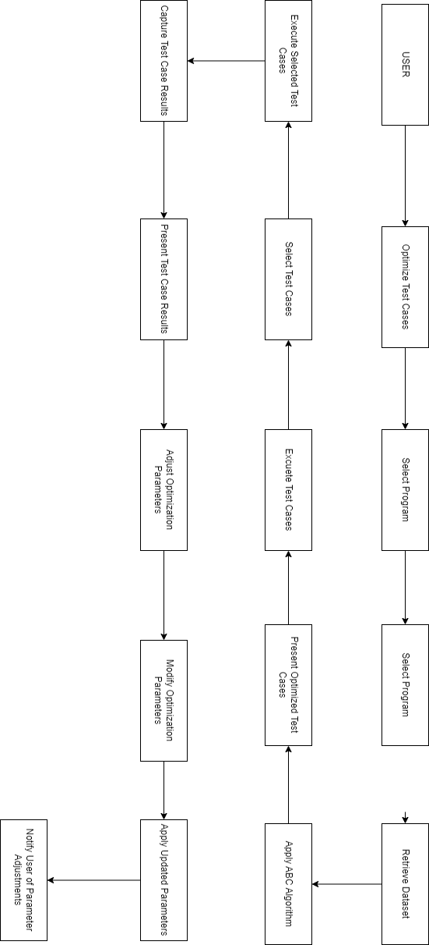
Fig 4.3 Use Case View Model

Deployment View – PART-B

[This sub-section describes one or more physical network (hardware) configurations on which the software is deployed and run. It is a view of the Deployment model. At a minimum, for each configuration it should indicate the physical nodes (computers, CPUs) that execute the software, and their interconnections (bus, LAN, point-to-point, and so on.) Also include a mapping of the processes of the Process View onto the physical nodes.

This section also describes the deployment environment.]

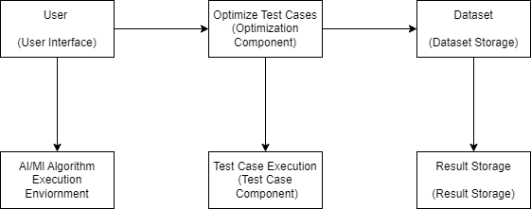

Fig 4.4 Deployment View Model of the project

Alternative Solutions Considered – PART-B

Alternative Solutions Considered:
Genetic Algorithm (GA): One alternative solution considered was using a Genetic Algorithm for test case optimization. GA is a search-based optimization algorithm inspired by the process of natural selection. It uses the concepts of population, fitness evaluation, selection, crossover, and mutation to iteratively evolve a population of potential solutions. In this case, GA could have been applied to generate and refine test cases based on the given criteria.
Particle Swarm Optimization (PSO): Another alternative solution considered was using Particle Swarm Optimization for test case optimization. PSO is a population-based optimization algorithm inspired by the social behavior of bird flocking or fish schooling. It involves particles moving in the search space to find the optimal solution. In this case, PSO could have been used to iteratively adjust the test cases to improve their fitness values.
Rationale for Selecting the Current Solution:
The Artificial Bee Colony (ABC) algorithm was chosen as the current solution for test case optimization due to several reasons:

Performance: The ABC algorithm has shown promising performance in solving optimization problems, especially when applied to combinatorial optimization. It exhibits good convergence characteristics and is suitable for continuous and discrete search spaces.

Simplicity: The ABC algorithm is relatively simple to implement and understand compared to other optimization techniques. It involves the concept of employed bees, onlooker bees, and scout bees, making it intuitive to grasp.

Effectiveness: The ABC algorithm has been successfully applied to various optimization problems and has demonstrated competitive results. Its ability to explore the search space and exploit promising solutions makes it well-suited for the test case optimization problem.

Flexibility: The ABC algorithm can be easily customized and adapted to specific problem domains by adjusting parameters and fitness functions. It provides the flexibility to incorporate domain-specific knowledge and constraints into the optimization process.

